Primary Audience: Mentor
Purpose of Document: This guide outlines the steps for the mentor completing the professional development plan

Mentoring another teachers Professional Development Plan
- Click on the Staff Evaluations tab.

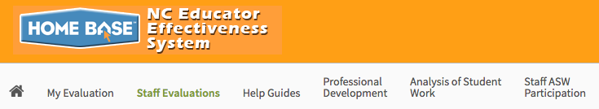

- Choose evaluation plan type Professional Development Plan of the current school year.

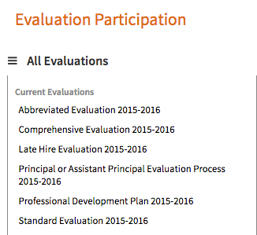

- In the Professional Development Plan Evaluation channel, click on teacher name.

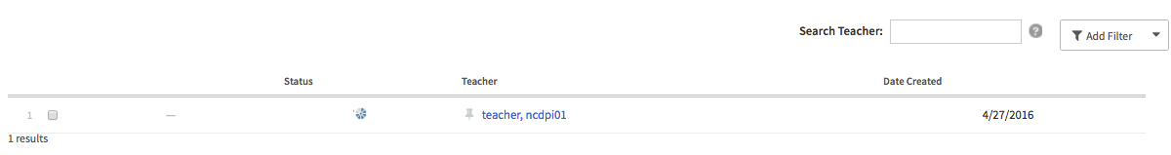

Completing the Professional Development Plan

The following containers display the required steps of the Professional Development Plan:

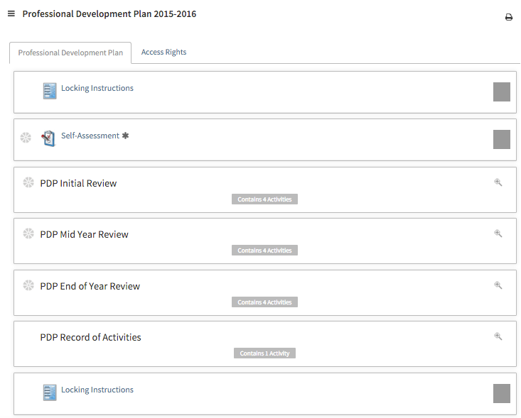

The following status icons can be found throughout the evaluation plan in the system. Keep these in mind when completing the activities within the containers.

Step 1: Self-Assessment
Completed by the teacher at Beginning of the Year (this may be shared with you) to access click Self-Assessment.

Steps 2: PDP Initial Review

Click anywhere in the PDP container to expand the activities.
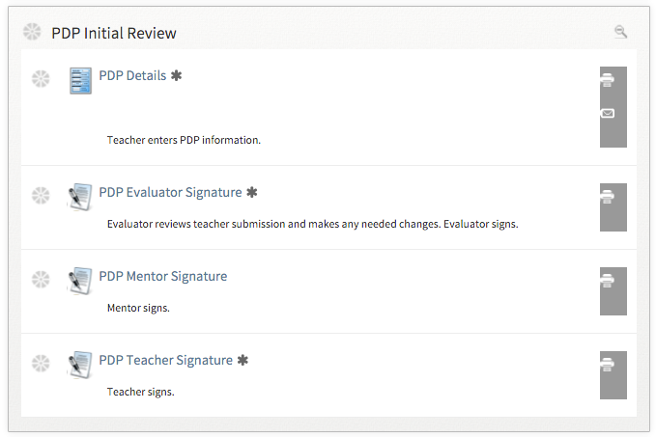

Activity 1: PDP Details
Once the teacher has completed the PDP details, there will be a green check mark in that activity. Click on PDP Details to view this step. Click Back when done.

Activity 2: PDP Evaluator Signature
Once the Evaluator has completed the PDP Signature steps, there will be a green check mark in that activity. Click on PDP Evaluator Signature to view this step. Click Back when done.

Activity 3: Mentor Signature

1. Review the Professional Development Plan details.
2. Review the Teacher strategies and evaluator comments.

3. Click on New to enter comments.

- Enter comments in the box and upload any documents using the attach button.

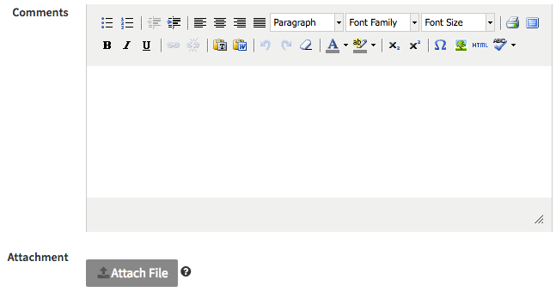

5. Click Save & Exit to return to the container.
6. Once you have reviewed your comments, click the Acknowledge button to sign off.

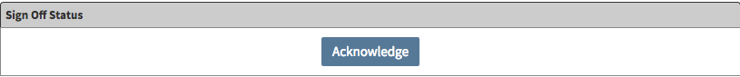

7. Click Mark Complete to finish this step.

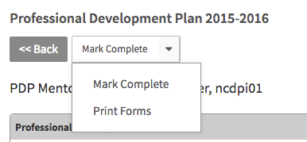

Activity 4: PDP Teacher Signature
Once the teacher has completed the PDP Signature steps, there will be a green check mark in that activity. Click on PDP Teacher Signature to view this step. Click Back when done.

Step 3: PDP Review Mid-year

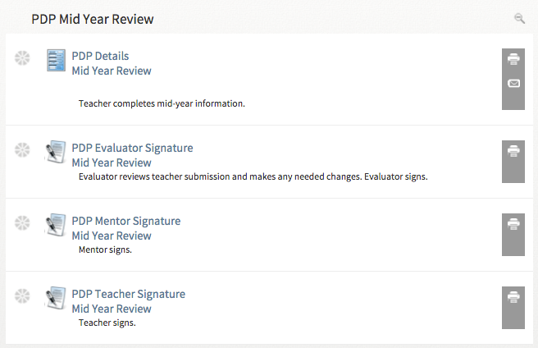

Activity 1: PDP Details Mid Year Review
Once the teacher has completed the PDP details, there will be a green checkmark in that activity. Click on PDP Details to view this step. Click Back when done.

Activity 2: PDP Evaluator Signature Mid Year Review
Once the Evaluator has completed the PDP Signature steps, there will be a green checkmark in that activity. Click on PDP Evaluator Signature to view this step. Click Back when done.

Activity 3: Mentor Signature Mid Year Review

      - Click PDP Mentor Signature Mid Year Review.

      - Review the Professional Development Plan details. Review the Teacher strategies and evaluator comments.
3. Click on New to enter Mentor Comments – Mid Year.

- Enter comments in the box and upload any documents using the attach button.

5. Click Save & Exit to return to the container.
6. Once you have reviewed your comments, click the Acknowledge button to sign off.

7. Click Mark Complete to finish this step

Once the mentor signature step is complete a green checkmark will appear.

Activity 4: PDP Teacher Signature Mid Year Review
Once the teacher has completed the PDP Signature steps, there will be a green checkmark in that activity. Click on PDP Teacher Signature to view this step. Click Back when done.

Step 4: PDP Review End of Year

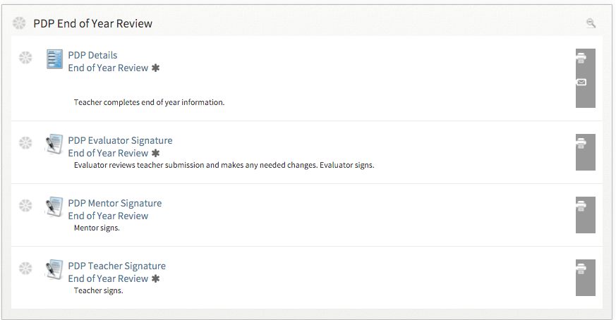

Activity 1: PDP Details End of Year Review
Once the teacher has completed the PDP details, there will be a green check mark in that activity. Click on PDP Details to view this step. Click Back when done.

Activity 2: PDP Evaluator Signature End of Year Review
Once the Evaluator has completed the PDP Signature steps, there will be a green check mark in that activity. Click on PDP Evaluator Signature to view this step. Click Back when done.

Activity 3: Mentor Signature End of Year Review

- Click PDP Mentor Signature End of Year Review.

- Review the Professional Development Plan details. Review the Teacher strategies and evaluator comments.
- Click on New to enter comments.

- Enter comments in the box and upload any documents using the Attach File button.

5. Click Save & Exit to return to the container.
6. Once you have reviewed your comments, click the Acknowledge button to sign off.

7. Click Mark Complete to finish this step.

Once the mentor signature step is complete a green checkmark will appear as indicated.

Activity 4: PDP Teacher Signature End of Year Review
Once the teacher has completed the PDP Signature steps, there will be a green check mark in that activity.

