BT End-of-Year Checklist

Documents:

BT End-of-Year Verification Form

BT Support Session Participation Form

BT Extra-Curricular Duties Agreement Letter

NCEES PDP Record of Activities

NCEES Record of Teacher Evaluation Activities

NCEES Summary Evaluation Form

BT End-of-Year Verification Form

http://bcsbt.weebly.com/end-of-year-documentation.html

BT Support Session Participation Form

http://bcsbt.weebly.com/end-of-year-documentation.html

BT Extra-Curricular Duties Agreement Letter

http://bcsbt.weebly.com/end-of-year-documentation.html

NCEES PDP Record of Activities

Step 1: Login to NCEES

Step 2: Select

Step 3: Select 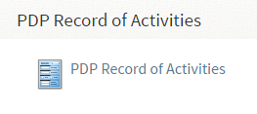

Step 4: Select 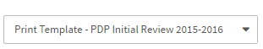

Step 5: Select pdf

Step 6: Select 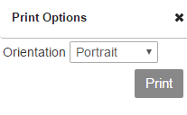

NCEES Record of Teacher Evaluation Activities

Step 1: Login to NCEES

Step 2: Select 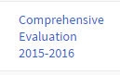

Step 3: Select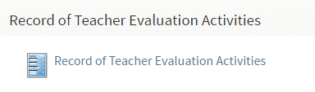

Step 4: Select

Step 5: Select pdf

Step 6: Select

NCEES Summary Evaluation Form

Step 1: Login to NCEES

Step 2: Select

Step 3: Select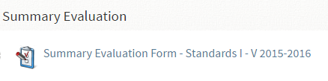

Step 4: Select pdf 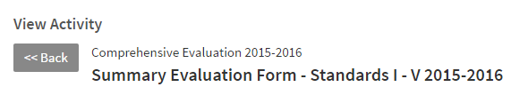

Step 5: Print

